Mrs. Land’s class
Parents…… Have a Smart Phone ?

Please use your barcode scanner to scan these QR codes to save important information to your phone.

My weebly My School ELA
Site Email Textbook

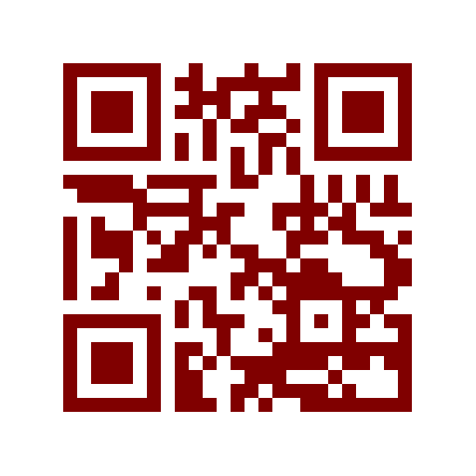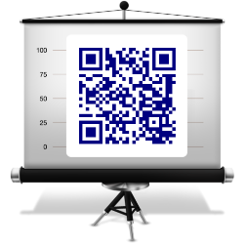

Want to stay connected?
For updates that are sent to your phone….please
sign up for Remind text messaging
to join the 7th Grade ELA reminders……
Text the number 81010 and enter the code
@26481

